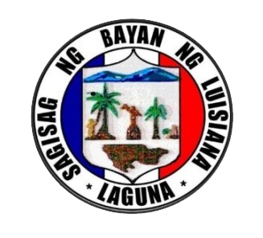

**LOCAL YOUTH DEVELOPMENT OFFICE**

Province of Laguna

MUNICIPALITY OF LUISIANA

*Contact Number: 555 – 3411* | *+63 915 36 13226*

**20 February 2019**

**RAMON B. VALDENARRO**

State Auditor IV

*Commission on Audit*

**Dear Sir Valdenarro,**

Greetings!

Last January 23, 2019 the Department of Budget and Management (DBM), Department of Interior and Local Government (DILG), and the National Youth Commission (NYC) have released the Joint Memorandum Circular (JMC) No.1, series of 2019 regarding the GUIDELINES ON THE APPROPRIATION, RELEASE, PLANNING AND BUDGETING PROCESS FOR THE SK FUNDS.

In this JMC, section 3.2 states that the SK funds shall be automatically released by the barangay to the SK. And also, consistent with Section 20 (b) of RA No. 10742, the SK shall open a current account in the name of the SK wherein the provisions of Department of Finance Department Circular No. 1-2017 dated May 11, 2017 shall be strictly observed.

Furthermore, the SK funds shall be deposited by the barangay in the current account of the SK not later than five (5) working days after the crediting of the monthly internal revenue allotment (IRA) share of the barangay consistent with the rules and regulations issued by the Commission on Audit (COA).

However, COA has not yet released any guidelines on how the barangay will transfer the SK funds to the current account of the SK.

With this, we politely ask on **how the Sangguniang Kabataan will disburse from the SK Fund given that COA has yet to release the said guidelines.**

We hope to receive any response from your office, the soonest possible time.

Thank you very much.

In the Service of the Filipino Youth,

**ALVIN FRANZ FAMINIAL**

*Municipal Youth Development Officer - Designate*